Extended Binary Tree
Extended binary tree is a type of binary tree in which all the null sub tree of the original tree are replaced with special nodes called external nodes whereas other nodes are called internal nodes
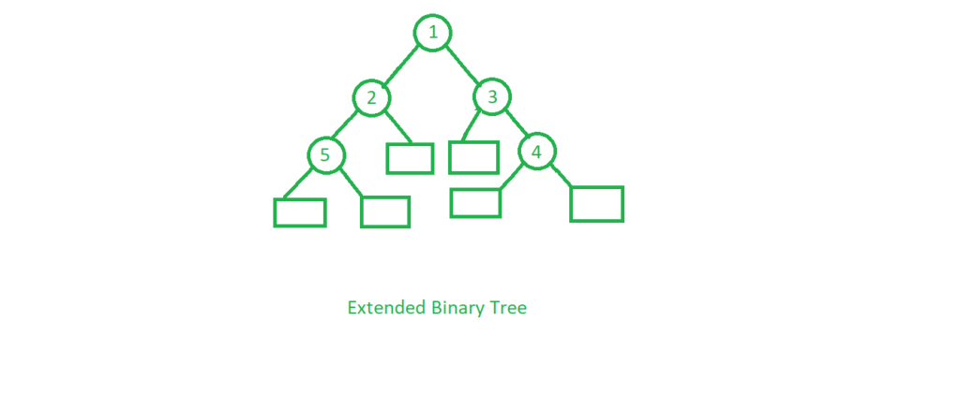
Here the circles represent the internal nodes and the boxes represent the external nodes.
Properties of External binary tree
- The nodes from the original tree are internal nodes and the special nodes are external nodes.
- All external nodes are leaf nodes and the internal nodes are non-leaf nodes.
- Every internal node has exactly two children and every external node is a leaf. It displays the result which is a complete binary tree.
Uses:
1. It is useful for representation in algebraic expressions.
Below is an example of making an extended binary tree in C++ by making all the external nodes as ‘-1’
// Java program to make an extended binary tree
class GFG
{

// A Tree node
static class Node
{
int key;
Node left, right;
};

// Utility function to create a new node
static Node newNode(int key)
{
Node temp = new Node();
temp.key = key;
temp.left = temp.right = null;
return (temp);
}

// Function for inorder traversal
static void traverse(Node root)
{
if (root != null)
{
traverse(root.left);
System.out.print(root.key + " ");
traverse(root.right);
}
else
{

// Making external nodes
root = newNode(-1);
System.out.print(root.key + " ");
}
}

// Driver code
public static void main(String args[])
{
Node root = newNode(1);
root.left = newNode(2);
root.right = newNode(3);
root.left.left = newNode(5);
root.right.right = newNode(4);

traverse(root);
}
}

// This code is contributed by Arnab Kundu
Output:
-1 5 -1 2 -1 1 -1 3 -1 4 -1

Time Complexity: O(N).
Auxiliary Space: O(N).
Application of extended binary tree:
- Calculate weighted path length: It is used to calculate total path length in case of weighted tree.
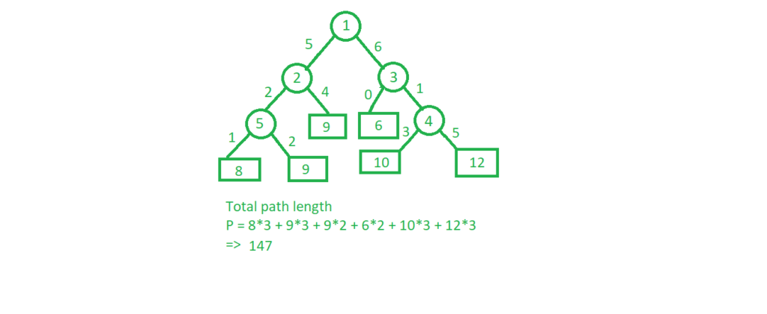
- Here, the sum of total weights is already calculated and stored in the external nodes and thus makes it very easier to calculate the total path length of a tree with given weights. The same technique can be used to update routing tables in a network.
- To convert binary tree in Complete binary tree: The above-given tree having removed all the external nodes, is not a complete binary tree. To introduce any tree as complete tree, external nodes are added onto it. Heap is a great example of a complete binary tree and thus each binary tree can be expressed as heap if external nodes are added to it.

